**Year 3 and 4 Autumn 1 Pick and Mix Home Learning**

**The Rotten Romans**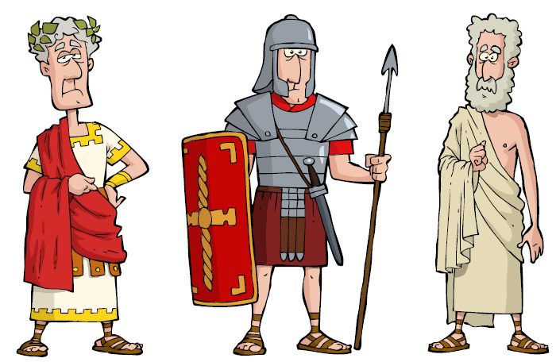

* Choose your weekly homework from the menu below
* Homework is due back to school no later than the following Wednesday
* All activities need to be completed across the half-term
* Challenge yourself with activities *at least* once across the half-term.
* In addition, reading should be completed regularly and logged in your Planner.
* Maths and spellings will be expected to be completed weekly. (separate sheets)

|  |  |
| --- | --- |
| **Topic** | **English** |
| Draw yourself as a Roman. You can be anybody you like, a God/Goddess, a soldier, a slave, Emperor. | Write an acrostic poem about something Roman. |
| If you were a Roman Emperor what new laws would you make and why? | Visit the library and write a review of your book. [Image result for library clipart](https://www.google.co.uk/url?sa=i&rct=j&q=&esrc=s&source=images&cd=&cad=rja&uact=8&ved=0ahUKEwjpo8bv7vHSAhUjIcAKHWpICDEQjRwIBw&url=http://www.clipartpanda.com/categories/library-clipart&bvm=bv.150729734,d.ZGg&psig=AFQjCNE_bxJc7nbNK6P-PxM_4hUCCWtBxA&ust=1490538529099208) |
| Find a Roman recipe and make it. Please take a photo so we can see it. What did it taste like? Did you enjoy it? | Write a fact file about a Roman God or Goddess. |
| Write a secret message using Roman Numerals instead of letters (Ask if you need a list of Roman numerals) | Write a diary entry, imagining that you are a Roman soldier who has spent a very long time at war and away from his family. |
| Create a Roman sword, shield, helmet or body armour. | Compare Roman life to life today. Write a list of similarities and differences. |
| Create a Roman Toga using an old bed sheet, take a photo of you wearing it. | Create a poster, encouraging boys to sign up to the Roman Army. |
| Create an outdoor game for a Roman child to play. | The Romans improved life in England, research how they did this. |
| Design a Roman flag using images of Roman objects. | Imagine you are a person living in a British village that is taken over by the Romans. Write a letter to a family member or friend telling them what happened and how you feel about it. |